***Problem Statement :*** Write a Program in Python to apply Bubble Sort Algorithm

***Objective :*** To Write a Program in Python for Bubble Sort Algorithm

***Source Code & Input-Output :***

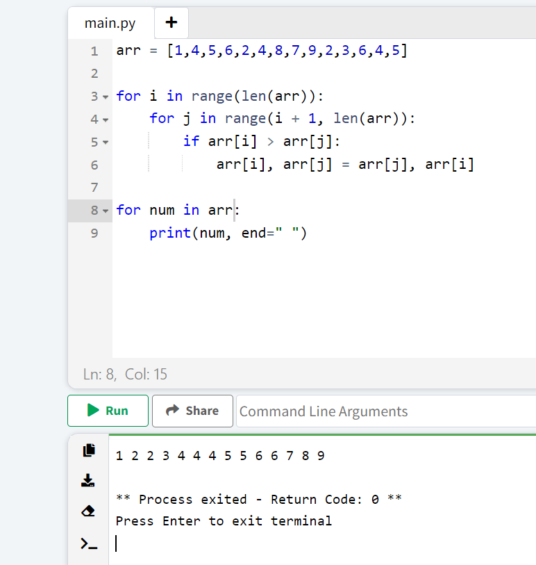

***Problem Statement :*** Write a Program in Python to apply Insertion Sort Algorithm

***Objective :*** To Write a Program in Python for Insertion Sort Algorithm

***Source Code & Input-Output :***

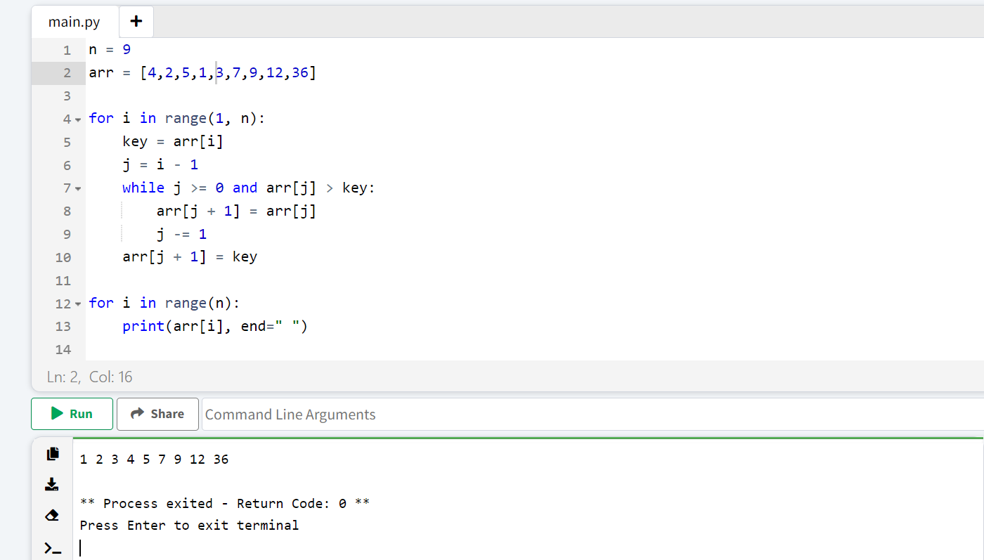

***Problem Statement :*** Write a Program in Python to apply Selection Sort Algorithm

***Objective :*** To Write a Program in Python for Selection Sort Algorithm

***Source Code & Input-Output :***

